Final Project Report
Course: DATS 6312.11- NLP
Members: Abirham Getie, Julio Montoya

Sentiment Analysis of Financial News Headlines
1.Introduction
Financial markets react strongly to the tone and sentiment expressed in news headlines. Positive news can increase investor confidence, while negative news can trigger sell-offs. In traditional investing, analysts rely on Fundamental Analysis. The evaluation of a company’s intrinsic value using financial statements, economic conditions, and broader market factors to understand long-term growth potential. However, day-to-day market movements are also heavily influenced by short-term sentiment and investor psychology.
At the beginning, we used a sample dataset of 10,000 rows because the full dataset contains 1.8 million rows, and we were working in PyCharm with Google Cloud resources. However, after the presentation and your feedback, we decided to try to use the whole dataset to get better result and more confident model and results. Despite spending many hours, the GCP–PyCharm environment repeatedly failed when processing the full dataset. To accomplish this, we switched to Google Colab Pro and utilized its A100 GPU, which allowed us to train and test our models using the full dataset 1.8 million-row dataset.
The goal of this project is to use NLP techniques to assign positive, negative, or neutral sentiment to financial news headlines and to analyze how these sentiment trends may correspond to movements in the financial markets. Looking for specific patterns.
2.Dataset
Dataset: Massive Stock News Analysis Database (Kaggle)

Link:https://www.kaggle.com/datasets/miguelaenlle/massive-stock-news-analysis-db-for-nlpbacktests?select=raw_partner_headlines.csv
Dataset description:
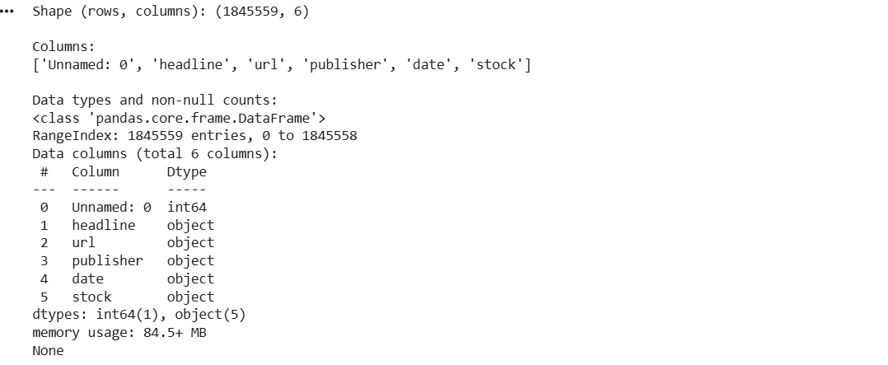

We use the “Massive Stock News Analysis Database for NLP Backtests” dataset from Kaggle, specifically the raw_partner_headlines.csv file as it is shown in Fig 1. This dataset contains approximately 1.8 million English-language news headlines related to publicly traded stocks. Each row corresponds to a single news headline and includes metadata such as the publication date, time, associated ticker symbol, the headline text, and the news provider/source.
This large-scale dataset is designed for financial NLP tasks and backtesting strategies, making it well suited for our goal of financial sentiment classification. In our project, we first experimented with a 10,000-row sample for faster prototyping and debugging. After incorporating presentation feedback, we moved to using the full 1.8M-row dataset to train and evaluate our models more reliably and to reduce sampling bias.
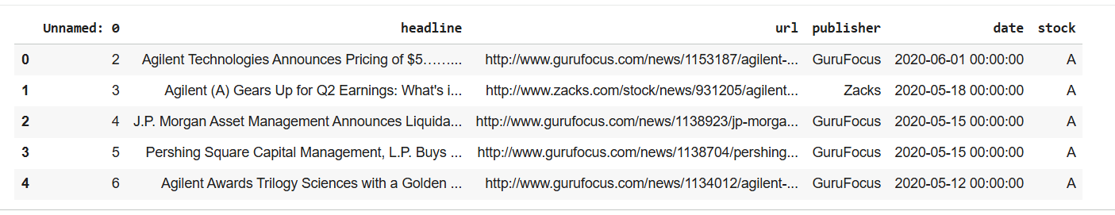
Figure 1.raw data set head
Our dataset was originally unlabeled, meaning it did not contain any sentiment annotations required for supervised sentiment analysis. To create high-quality labels suitable for training modern NLP models, we used FinBERT, a transformer model specifically designed for financial sentiment understanding. FinBERT generates sentiment predictions (positive, neutral, negative) based on financial-language patterns, which allowed us to automatically label all 1.8 million headlinesas it is shown in Figure 2.
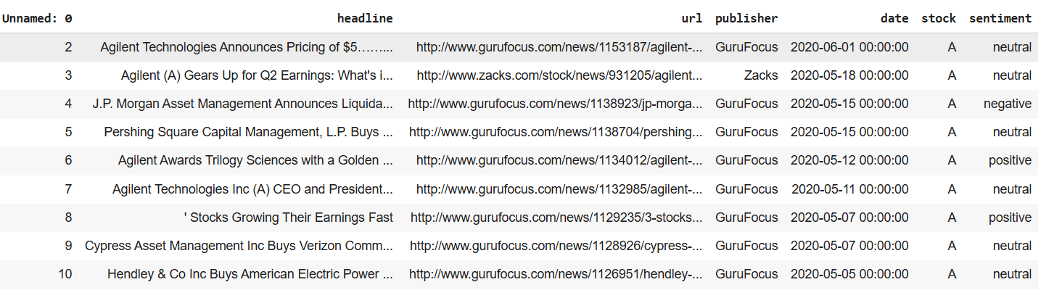
Figure 2. Labeled data head
To evaluate how effective these automatically generated labels were, we introduced a benchmark dataset—the Financial PhraseBank from Hugging Face (https://huggingface.co/datasets/takala/financial_phrasebank). This dataset is manually curated by financial experts and is a widely accepted standard for financial sentiment analysis. Using our evaluation pipeline, FinBERT achieved strong performance on PhraseBank, confirming that it is a reliable teacher model for large-scale labeling. We also compared the sentiment distribution of our automatically labeled 1.8M-row dataset with the distribution in Financial PhraseBank and observed similar overall trends, which further supports the consistency of the labelling process.
In addition, we analysed FinBERT’s confidence scores, identified low-confidence or ambiguous headlines, and examined keyword patterns and temporal sentiment trends. Together, these checks confirmed that our pseudo-labels are stable enough for downstream model training. FinBERT achieves 97.2% accuracy on the expert-annotated Financial PhraseBank dataset, showing excellent agreement with human labels. This validates FinBERT as a reliable model for generating high-quality sentiment labels for our 1.8M-row dataset.
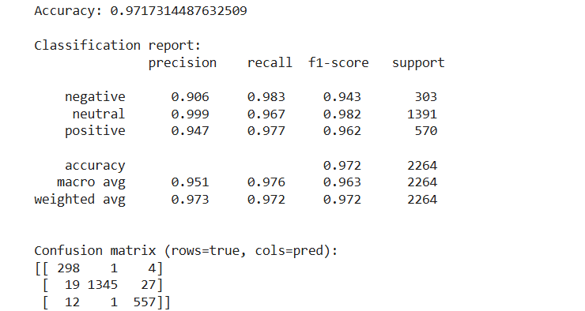

3. Exploratory Data Analysis
3.1 Sentiment Distribution Charts.

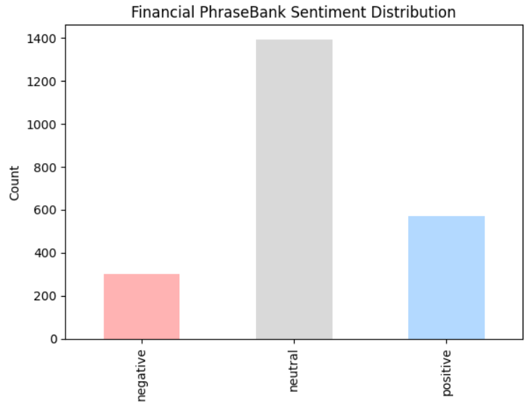
This chart shows that in the Financial PhraseBank dataset, neutral statements make up the majority of the headlines (60% aprox.) followed by positive statements (25%), while negative statements are the least with around 15%. This imbalance reflects the tendency of financial reporting to use neutral or factual language rather than strongly positive or negative sentiment.
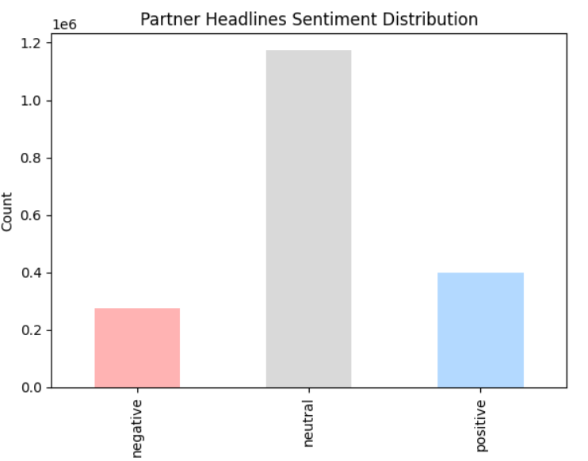The While in our main dataset, this chart illustrates that most of the partner headlines are neutral, with well over a million headlines falling into this category. Positive headlines are the next most common, while negative headlines make up the smallest group. Overall, the data suggests that financial news sources tend to write in a neutral, factual tone much more often than they use clearly positive or negative language.
3.2 Sentiment by Publisher
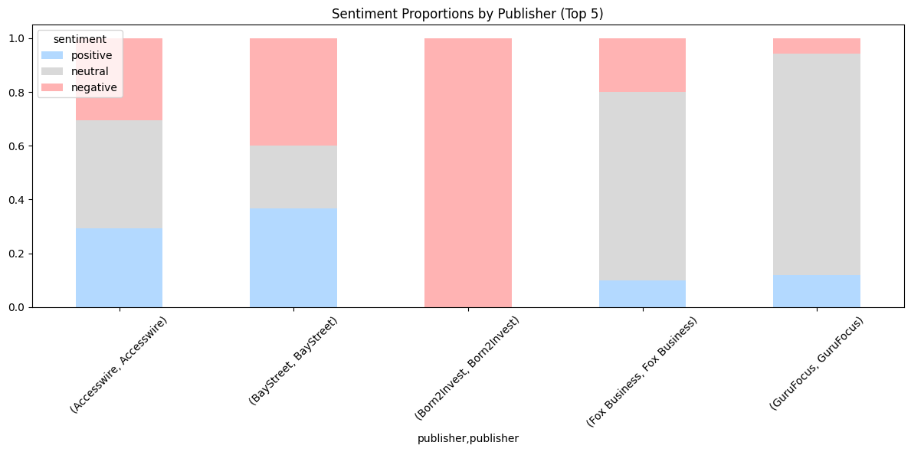

This stacked bar chart shows the sentiment distribution for the top five publishers in our dataset. The first three publishers display a strong tendency toward negative headlines. However, for the fourth and fifth publishers, we can see that neutral headlines are the most common. In summary, there is not a clear pattern, it varies in the top 5 publishers. For instance, Born2Invest is completely negative, indicating that this publisher consistently reports market risks and slides. Fox Business and GuruFocus focus on neutral which represents their higher proportion and Accesswire and BayStreet show more balanced sentiment.
3.3 Monthly Sentiment Over the years
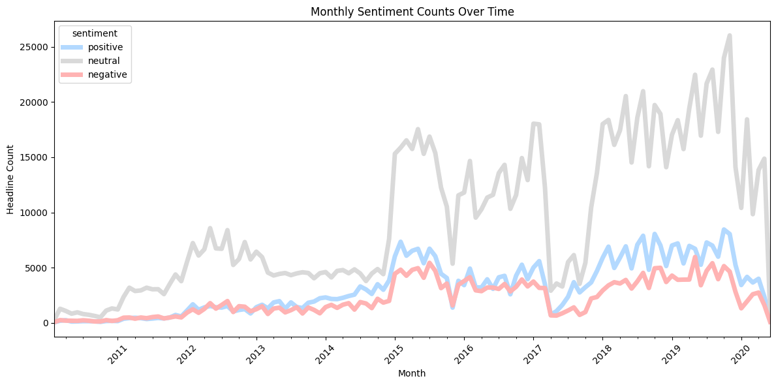

This chart depicts that Neutral headlines consistently appear most often, reflecting the fact that much financial reporting is descriptive rather than strongly positive or negative. Both positive and negative headlines also rise over time. This is impact of the internet and social media boom. There is a clear tendency of growth of positive and negative financial news production, but they remain below neutral levels.

3.4 Word Cloud Visualization
Word clouds were generated for each sentiment class to visualize the most frequent terms. This helps identify common themes and provides quick qualitative insights into the language structure of financial headlines.
- Positive headlines: “earning” “beat,” “higher”,” revenue” and “dividend”
- Negative headlines :“downgraded” “lower”, “low sales”, “decline”
- Neutral headlines: “Stock”, “analyst, “report”, “CEO” and “Portfolio”
It is important to mention that some words, including “stock,” “earnings,” and “blog,” as well as quarterly references such as Q1–Q4, appear across all sentiment categories due to their general relevance in financial reporting.
Overall, the word clouds reinforce the quantitative findings and illustrate the typical language patterns associated with each sentiment class.
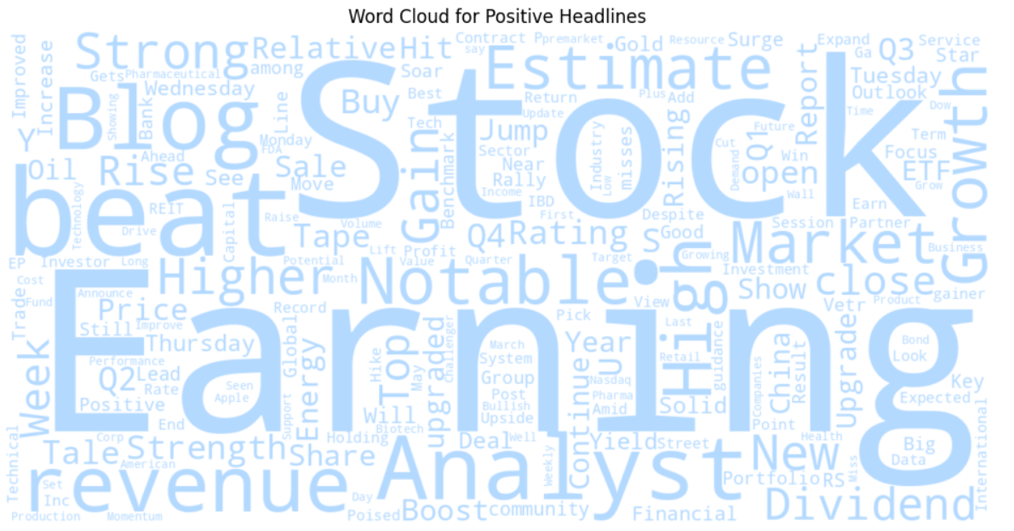
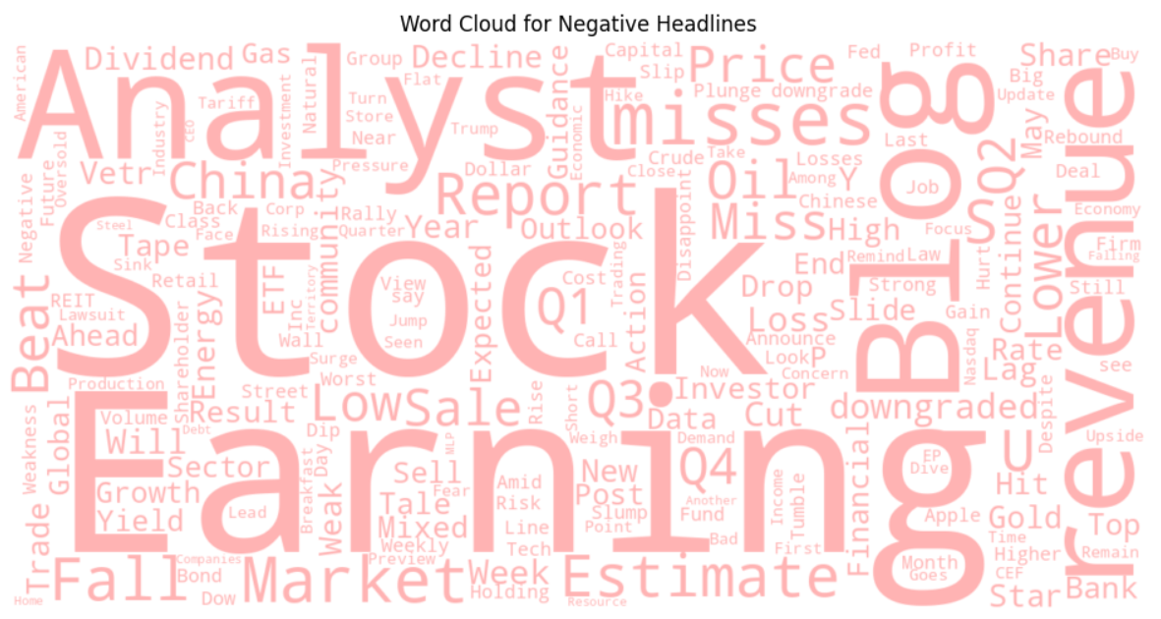



3.5 Confidence distribution chart
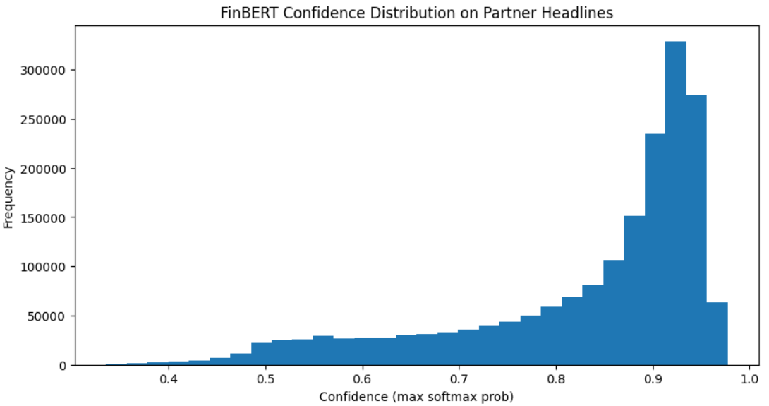
The confidence distribution shows that FinBERT assigns very high confidence scores to most predictions on the 1.8M-row dataset, with the majority of headlines receiving probabilities above 0.85. This indicates that FinBERT is generally certain about its sentiment decisions. Only a small fraction of headlines fall below 0.6 confidence, suggesting relatively few ambiguous or borderline cases.
FinBERT outputs a vector of logits $z=(z_{1},z_{2},z_{3})$for the three sentiment classes.
These are converted into probabilities using the softmax function:
$$p(y=k∣x)=\frac{e^{z_{k}}}{\sum_{j=1}^{K}{}e^{z_{j}}}$$
Where:
- $K=3$sentiment classes
- $z_{k}$is the logit for class $k$
- $p(y=k∣x)$is the model’s confidence for that class
The maximum softmax probability (MSP) is then used as the model’s confidence score:
$$\text{Confidence}(x)=\underset{k∈\{1,2,3\}}{max⁡}p(y=k∣x)$$

This value show that how certain the model is about the predicted sentiment. Analyzing the confidence distribution allows us to assess the reliability of the pseudo-labels generated for our 1.8M-row dataset. High-confidence predictions indicate that FinBERT assigns a dominant probability to one class, suggesting strong signal and stable labeling. Low-confidence shows highlight ambiguous or sentiment-mixed headlines.

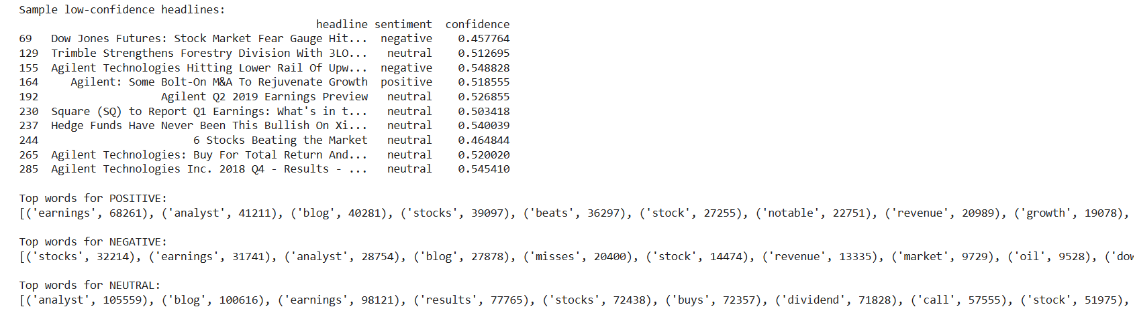
A small subset of headlines receives low confidence scores (<0.55), typically because they contain mixed signals, market reports, or ambiguous financial wording. These examples illustrate the kinds of headlines where even a domain-specific model like FinBERT struggles to assign a clear sentiment label.
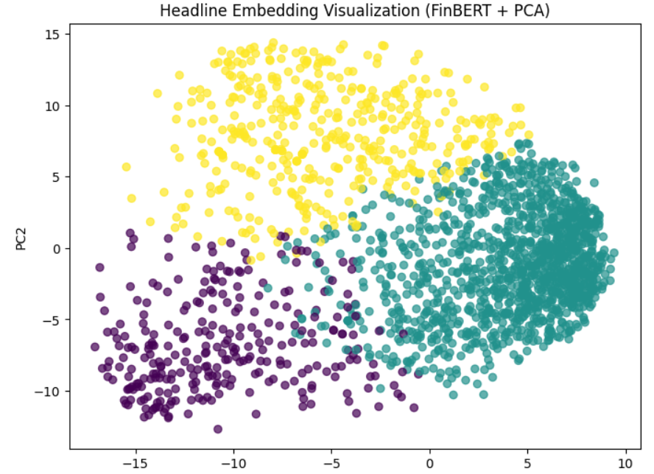
The above PCA projection of FinBERT sentence embeddings shows clear clustering patterns corresponding to the three sentiment classes of our data set. Even after reducing the 768-dimensional embedding space to just two principal components, the positive, neutral, and negative headlines form largely separable regions. This separation suggests that FinBERT captures meaningful semantic structure in financial text, providing evidence that the pseudo-labels are grounded in real embedding differences. Such visual separability is a strong indicator that the labeling model is internally consistent and suitable for downstream supervised training.
Preprocessing:
We preprocess the full 1.8M-row dataset, performing the complete preprocessing pipeline, including cleaning text, fixing date formats, removing duplicates and invalid rows,.After that we use FinBERT for labelling as it shows below.
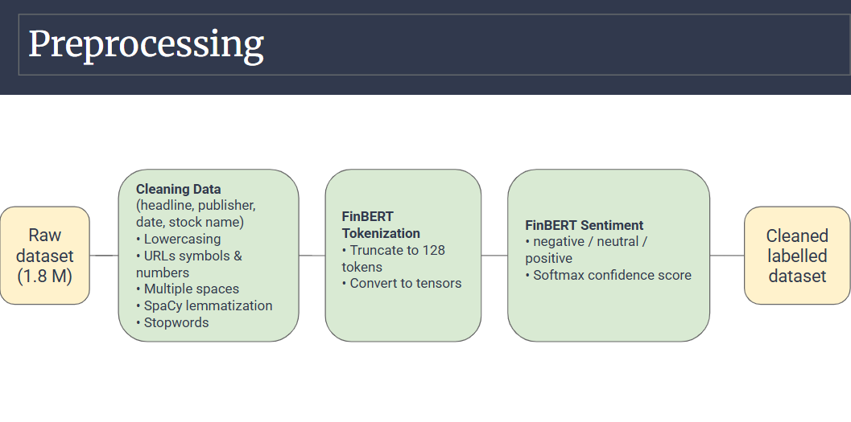
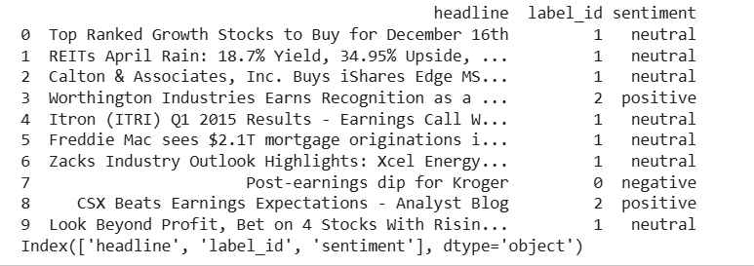
This sample shows the cleaned and structured dataset after preprocessing. Missing or malformed rows were removed, text was standardized, and FinBERT-generated sentiment labels (label_id and sentiment) were added to prepare the data for modeling.
Train, Test and Split:
After generating sentiment labels, we divided the dataset into train, validation, and test splits using stratified sampling. Stratification ensures that each split preserves the original sentiment distribution. As shown, the proportions of neutral (~63.5%), positive (~21.5%), and negative (~14.9%) examples remain consistent across all three splits. This consistency is important because it prevents class imbalance issues during training and ensures that model evaluation reflects the true distribution of the dataset.
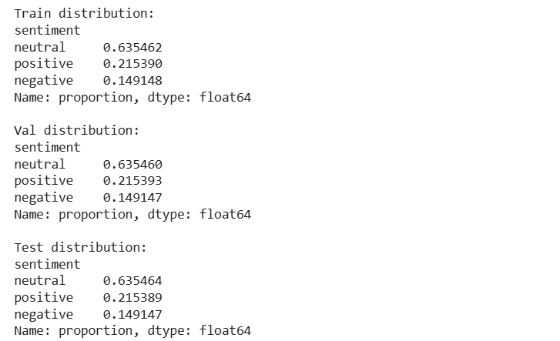

4. Modeling
4.1 Classical Baseline Model (TF-IDF + Logistic Regression)
To establish a benchmark, I implemented a classical NLP pipeline using TF-IDF feature extraction and Logistic Regression classification. TF-IDF converts text into sparse numerical vectors by weighting tokens according to their relative importance, while Logistic Regression provides a strong baseline for linear decision boundaries in high-dimensional spaces. It does not learn contextual embeddings but offers fast training and interpretability. It served as a quantitative reference point against which the Transformer-based model could be compared. It achieved an accuracy of 0.80 with our sample 10k data set and its accuracy got improved with full data set and achieved an accuracy of 0.86. 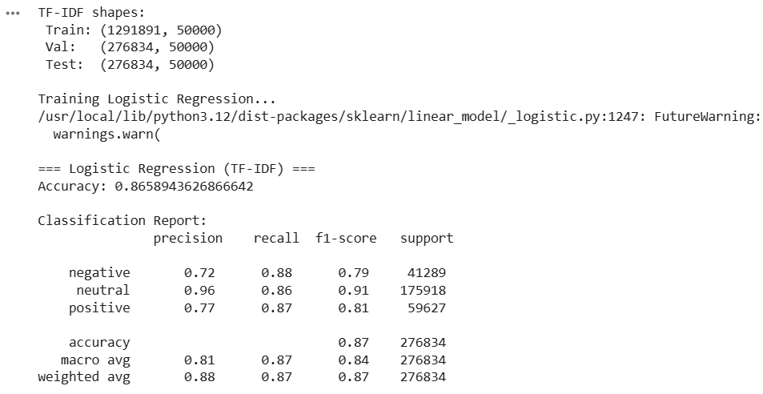
4.2 BILSTM
As part of our modeling experiments, we also implemented a Bidirectional LSTM (BiLSTM) model, which is a classical deep learning architecture widely used for sequence modeling tasks before transformer-based models became dominant. BiLSTMs capture contextual information from both the left and right directions of a sentence, making them a strong baseline for text classification tasks such as sentiment analysis. This model served as a traditional deep-learning comparison point alongside our transformer-based approach as shown below.

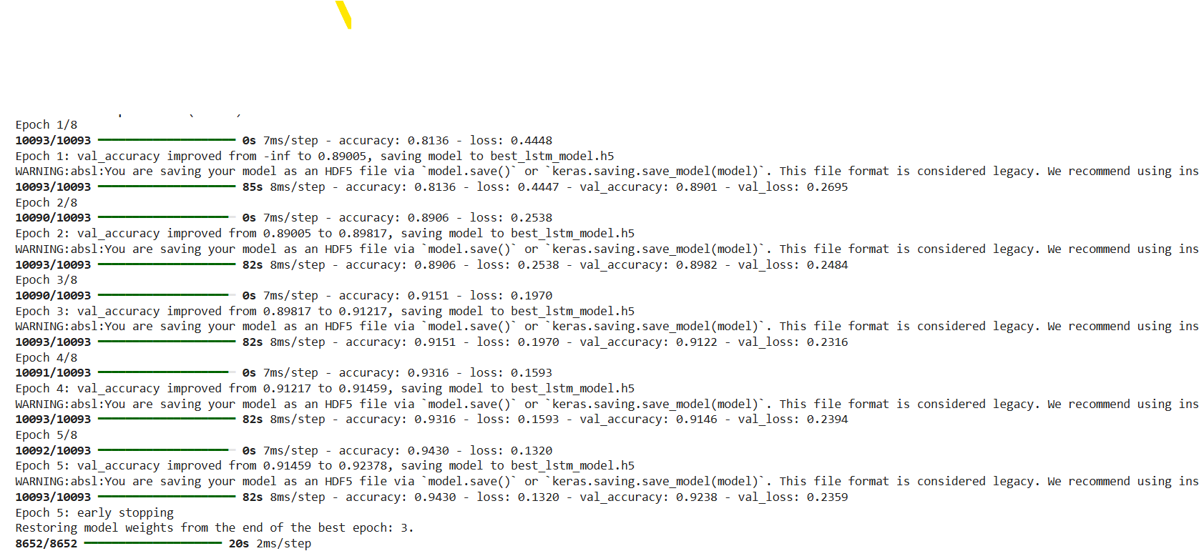
Figure : BILSTM Model Training
The BiLSTM model was trained using the Keras framework with a maximum limit of 8 epochs. The training process utilized two critical callbacks to ensure optimal performance ModelCheckpoint and EarlyStopping. As seen in the training log, the model demonstrated rapid convergence. By the end of the first epoch, the model achieved a validation accuracy of approximately 89%. The training continued to improve until Epoch 5, where the system triggered Early Stopping.
Although the model reached a peak training accuracy of 94.30% and a validation accuracy of 92.38% at Epoch 5, the system restored the model weights from Epoch 3. This decision was based on the Validation Loss metric, which reached its global minimum of 0.2316 at Epoch 3. Restoring the weights from Epoch 3 indicates that while the model continued to become more confident in later epochs (higher accuracy), it began to drift slightly in terms of generalized error (loss). By reverting to Epoch 3, the final model balances high accuracy (~91.5%) with the lowest possible error, ensuring the BiLSTM generalizes well to new, unseen data rather than overfitting to the training set.
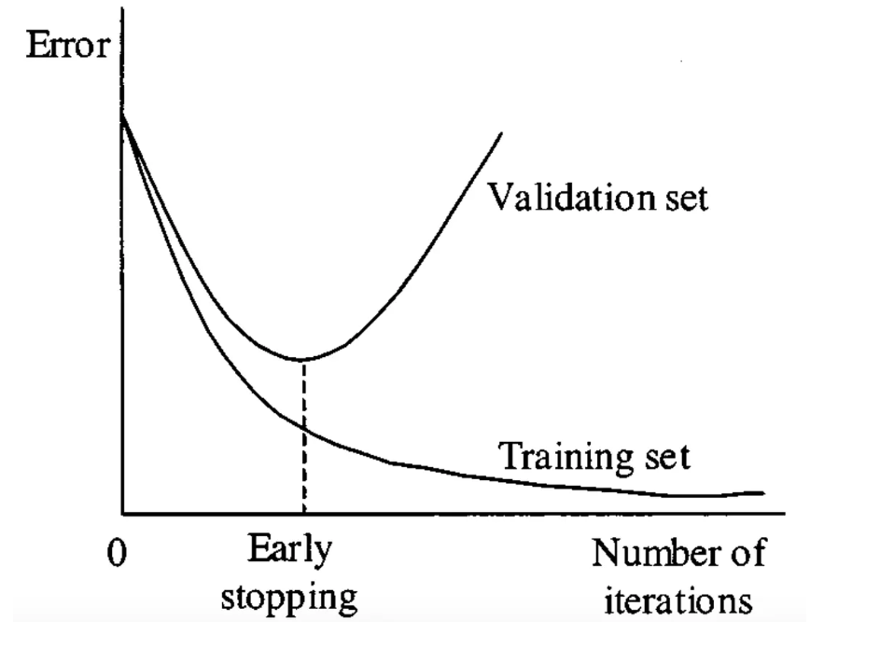
Fig : Early Stopping
As it is shown in Fig If the performance on the validation set starts to degrade (e.g., the loss increases or the accuracy decreases), it’s an indication that the model is beginning to overfit the training data. At this point, early stopping is triggered, and the training process is halted. Since the training is stopped before overfitting occurs, the model at the point of early stopping is typically the best model, as it has not yet learned the noise in the training data
Model Parameters:
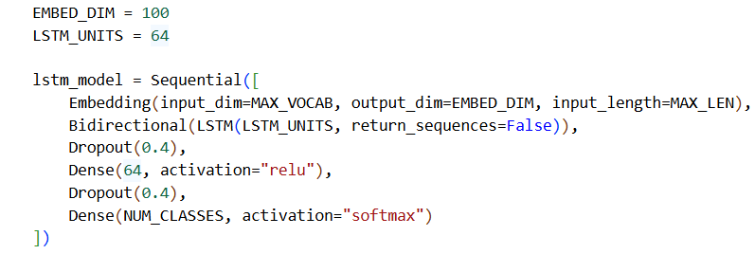Output of BiLSTM:
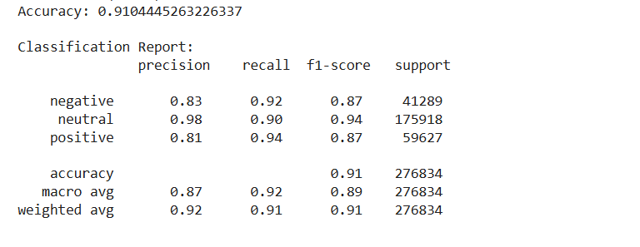

4.3 Transformer Model
Transformer Model Unlike the BiLSTM architecture, which processes data sequentially, the Transformer model relies entirely on a self-attention mechanism to draw global dependencies between input and output. This architecture allows for significantly more parallelization during training and overcomes the distance limitations associated with Recurrent Neural Networks (RNNs). By processing the entire sequence simultaneously, the Transformer captures complex, long-range relationships in the data more effectively, resulting in improved generalization and faster convergence.
In addition to the classical BiLSTM baseline, we implemented three transformer-based models, each representing a different stage of modern NLP modelling: -DistilBERT , FinBERT and BERT-base.
DistilBERT:
It is lighter and faster version of BERT that retains most of its contextual reasoning power. DistilBERT applies Transformer encoders to generate contextual embeddings using masked language modeling pretraining.
For this project, I loaded the pretrained distilbert-base-uncased weights and customized them through fine-tuning on our labeled financial headlines. Fine-tuning modifies both the classification head and deeper Transformer layers, allowing the model to specialize in domain-specific sentiment.
The Transformer architecture uses self-attention to compute relationships between all tokens in a sentence simultaneously. Formally, attention weights are computed as:
$$\text{Attention}(Q,K,V)=\text{softmax}(\frac{QK^{T}}{\sqrt{d_{k}}})V$$

The dot product QK^T measures the similarity between a specific token (Query) and all other tokens (Keys). The softmax function then normalizes these scores into probabilities (weights), ensuring the model focuses on the most relevant words while ignoring irrelevant noise.
Training Parameters:
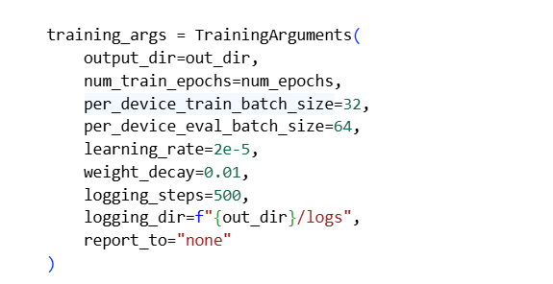
=== Validation metrics ===
{'eval_loss': 0.20406197011470795, 'eval_accuracy': 0.94518, 'eval_f1_weighted': 0.9453315840016969, 'eval_precision_weighted': 0.9455558941954135, 'eval_recall_weighted':0.94518,'eval_runtime':23.8148,'eval_samples_per_second': 2099.537, 'eval_steps_per_second': 32.837, 'epoch': 3.0}

DistilBERT achieved strong performance on our validation set, reaching an accuracy of 94.5% and a weighted F1-score of 0.945 after three epochs of fine-tuning. The close alignment between accuracy, precision, recall, and F1-score indicates that the model performs consistently across all sentiment classes without major class-specific bias. The low validation loss (0.204) further confirms that the model has effectively learned contextual patterns from financial headlines and generalizes well to unseen data.
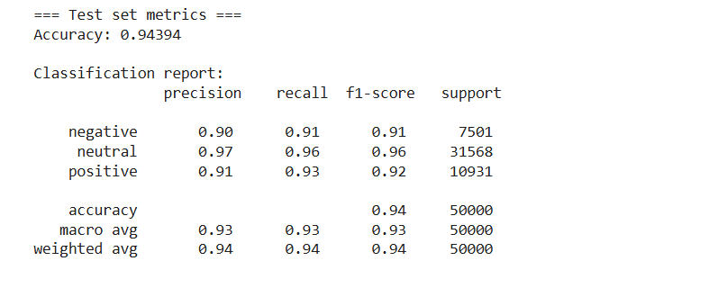
On the held-out test set, DistilBERT achieved an overall accuracy of 94.39%, confirming that its strong validation performance generalizes well to unseen data. The model performs consistently across all three sentiment classes, with F1-scores of 0.91 (negative), 0.96 (neutral), and 0.92 (positive). The close alignment between macro and weighted averages (both ≈0.93–0.94) indicates balanced performance despite the natural class imbalance in the dataset. These results demonstrate that DistilBERT effectively captures financial sentiment patterns and significantly outperforms traditional baseline models.It performed better than the classical models.
ProsusAI/FinBERT
ProsusAI/FinBERT is a domain-adapted version of BERT that has been further pretrained on large collections of financial text, such as earnings reports, investor statements, and market news. Because its training corpus is entirely finance-focused, FinBERT learns sentiment patterns and terminology that general language models often miss. This makes it particularly effective for sentiment analysis in financial contexts.
In our project, we used FinBERT in two major ways. First, as a teacher model, it generated sentiment labels for the full 1.8 million-row headline dataset. Its strong benchmark performance on the Financial PhraseBank (≈97% accuracy) gave us confidence that these pseudo-labels were reliable. Second, I used FinBERT during the modeling phase to examine embedding structures, perform confidence analysis, and validate whether the labeled data exhibited meaningful sentiment separation.
This made FinBERT not only the cornerstone of our labeling pipeline but also an essential analytical tool during my modeling work, helping us understand how sentiment patterns are encoded before training our downstream classifiers such as DistilBERT and BERT-Base.
The model achieved strong validation performance, with an accuracy of 95.73% and a weighted F1-score of 0.957 after three epochs of fine-tuning. The close alignment among precision, recall, and F1 indicates that the model performs consistently across all sentiment classes and does not suffer from class imbalance issues. The low validation loss (0.192) suggests that the model is effectively learning the underlying sentiment patterns in the financial headlines and is not overfitting. Overall, these metrics demonstrate excellent generalization on unseen validation samples.
=== Validation metrics ===
{'eval_loss': 0.19234080612659454, 'eval_accuracy': 0.95728, 'eval_f1_weighted': 0.9574602984852879, 'eval_precision_weighted': 0.9578070099711602, 'eval_recall_weighted': 0.95728, 'eval_runtime': 43.2126, 'eval_samples_per_second': 1157.069, 'eval_steps_per_second': 18.097, 'epoch': 3.0}
The model achieved 95.72% accuracy on the test set, confirming excellent generalization to unseen data. Performance is strong across all sentiment categories, with F1-scores of 0.93 (negative), 0.97 (neutral), and 0.94 (positive). The macro and weighted F1-scores (both 0.95–0.96) indicate that the model maintains balanced performance despite the natural class imbalance in the dataset. These results demonstrate that the model effectively captures financial sentiment patterns and ranks as the strongest among the models we evaluated.
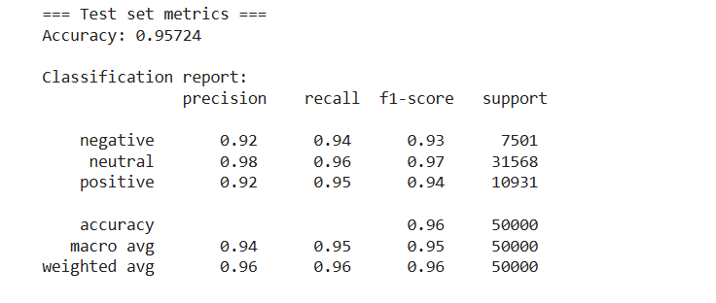
This model outperformed all other models in our pipeline, achieving the best accuracy (95.72%) and the most balanced class-wise F1-scores.

BERT-BASE-UNCASED Model:
In addition to DistilBERT and FinBERT, we also incorporated BERT-Base-Uncased into our modeling framework. BERT-Base is the original transformer encoder architecture developed by Google, consisting of 12 layers and 110 million parameters. It provides strong general-purpose language representations and serves as a widely accepted benchmark in NLP research. We included BERT-Base for two main reasons.
First, it acts as a conceptual and performance reference, allowing us to compare our lighter model (DistilBERT) and our domain-specific model (FinBERT) against a full-sized, general transformer baseline. This comparison helps demonstrate whether our chosen models retain the core strengths of the original architecture or achieve efficiency/performance trade-offs.
Second, both DistilBERT and FinBERT are derived directly from BERT-Base, using the base model provides helpful context for interpreting their behavior. DistilBERT compresses BERT-Base while maintaining most of its accuracy, and FinBERT adapts it to the financial domain. Including BERT-Base therefore allows us to understand how model size and domain specialization influence performance in financial sentiment classification.We have used the same parameters as the other models.
=== Validation metrics ===
{'eval_loss': 0.20731323957443237, 'eval_accuracy': 0.95178, 'eval_f1_weighted': 0.9520003712512309, 'eval_precision_weighted': 0.9524201351725875, 'eval_recall_weighted': 0.95178, 'eval_runtime': 43.2026, 'eval_samples_per_second': 1157.337, 'eval_steps_per_second': 18.101, 'epoch': 3.0}
BERT-Base achieved strong performance on the validation set, with an accuracy of 95.18% and a weighted F1-score of 0.952 after three epochs of fine-tuning. The close alignment among accuracy, precision, recall, and F1 indicates that the model is performing consistently across all sentiment classes without favoring any particular category. The validation loss of 0.207 is low, suggesting that BERT-Base is effectively learning the underlying sentiment patterns in financial text. Overall, these results confirm that the full-sized BERT model remains a strong baseline for financial sentiment classification.
Model Output:
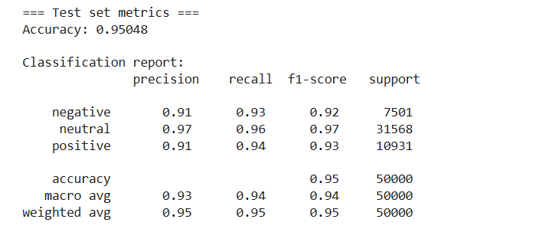
As it is shown above, On the held-out test set, BERT-Base achieved an accuracy of 95.05%, confirming excellent generalization beyond the validation stage. The model performs consistently across all three sentiment classes, with F1-scores of 0.92 (negative), 0.97 (neutral), and 0.93 (positive). The macro and weighted averages (both around 0.94–0.95) show that BERT maintains balanced performance despite class imbalance in the dataset. These results highlight BERT-Base’s strong ability to capture financial sentiment and demonstrate why it remains a high-quality reference architecture for transformer-based classification tasks.
Model Comparison:

Model | Validation Accuracy | Test Accuracy | Weighted F1 (Test)
TF-IDF + Logistic Regression | 0.82 | 0.80 | 0.80
BiLSTM | 0.91 | 0.90 | 0.90
DistilBERT | 0.945 | 0.9439 | 0.94
BERT-Base-Uncased | 0.9518 | 0.9504 | 0.95
FinBERT | 0.9573 | 0.9572 | 0.96

Transformer models performed better than the classical models and FinBERT is the best model from all others.

5. Summary
Below is a detailed breakdown of the work we
5.1 Classical Baseline Implementation on the sample 10k data set
I built the TF-IDF baseline using:
- TF-IDF (1–2 n-grams, max_features=20,000)
- Logistic Regression with balanced class weights and max_iter=1000
The baseline provided a reference point for accuracy and class performance before transitioning to deep learning.
Logistic Regression Model output:
Validation Performance
TF-IDF + Logistic Regression Validation Metrics
- Accuracy: 0.8003
- Macro-F1: 0.7378
Classification Report (Validation Set):
Class | Precision | Recall | F1-score | Support
Negative | 0.90 | 0.84 | 0.87 | 910
Neutral | 0.75 | 0.77 | 0.76 | 399
Positive | 0.52 | 0.67 | 0.58 | 178
Accuracy |  |  | 0.80 | 1,487
Macro Avg | 0.72 | 0.76 | 0.74 | 1,487
Weighted Avg | 0.81 | 0.80 | 0.81 | 1,487

Test Performance
TF-IDF + Logistic Regression Test Metrics
- Accuracy: 0.8023
- Macro-F1: 0.7460
Classification Report (Test Set):
Class | Precision | Recall | F1-score | Support
Negative | 0.91 | 0.82 | 0.86 | 911
Neutral | 0.76 | 0.82 | 0.79 | 398
Positive | 0.51 | 0.69 | 0.59 | 178

We used Logistic Regression model as the baseline for this project. The model achieved 80% accuracy on both the validation and test sets. This demonstrates that the model can capture a reasonable portion of sentiment-related lexical patterns in financial headlines.
The model performance varied noticeably across the three sentiment categories. Negative headlines showed the strongest performance, with F1 scores in the mid-eighties, largely because negative financial language often contains direct and unambiguous signals such as terms associated with losses, declines, or warnings. Neutral headlines also achieved solid results. However, positive headline, remained the most challenging for the baseline model, with F1 scores in the high fifties. These headlines appear less frequently in the dataset and often express optimism through more subtle market cues or forward-looking statements, making them harder for a Bag-of-Words representation to distinguish from neutral reporting.

DistilBERT on Our Sample 10k Data Set
Fine-tuning was conducted using the AdamW optimizer with a learning rate of 2e-5, a batch size of 32, and six training epochs. A linear learning-rate scheduler with a warm-up phase (10% of total steps) was used to stabilize optimization during the early stages of training. Cross-entropy loss served as the objective function for multi-class classification. Throughout training, I monitored the training loss, validation loss, accuracy, and macro-F1 score to track learning progress and detect early signs of overfitting. These metrics provided a comprehensive view of how the model adapted to financial sentiment and guided adjustments to hyperparameters and training behavior.
Model Performance and Metrics
The model demonstrated consistent improvement across epochs even though not efficient as the whole Data Set:
Epoch | Train Loss | Val Loss | Val Acc | Val F1
1 | 0.2198 | 0.4053 | 0.8574 | 0.8193
2 | 0.1686 | 0.3901 | 0.8668 | 0.8195
3 | 0.1106 | 0.4331 | 0.8749 | 0.8333
Final test-set classification performance:
- Accuracy: 0.87
- Weighted F1: 0.88
- Macro F1: 0.84
We chose accuracy and F1-based metrics for evaluation since the dataset is imbalanced, and each sentiment class contributes differently to overall performance. Accuracy alone would overlook this imbalance, so macro-F1 helps us see how well the model performs across all classes, while weighted F1 reflects overall performance while still accounting for class proportions.
Compared to our baseline model, the improvement is substantial. The baseline model reached around 0.80 accuracy and a macro-F1 near 0.74, performing particularly well on negative and neutral headlines but struggling with positive sentiment. The fine-tuned model improves macro-F1 by roughly ten points, indicating that it captures sentiment distinctions more effectively, especially in cases where meaning depends on context rather than surface-level keywords. This reflects the advantage of contextual embeddings: while the baseline relies on token frequencies, the Transformer model leverages relationships between words, allowing it to better interpret subtle expressions of optimism or market shifts. Overall, the fine-tuned model provides a clear performance lift and demonstrates the value of adapting pretrained Transformer architectures to domain-specific financial text.
Confusion Matrix on Sample Data Set:
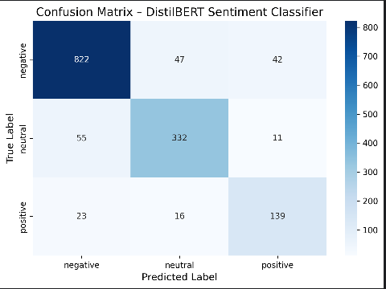
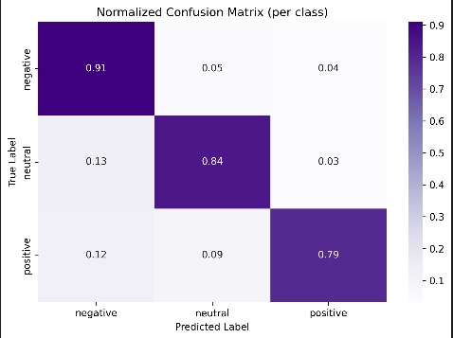

The confusion matrix illustrates the model’s performance across the three sentiment classes. The raw matrix shows the distribution of correct and incorrect predictions, while the normalized version highlights the proportion of correctly classified samples within each class. Together, they show that the model performs strongest on negative and neutral headlines, achieving 91% and 84% class-level accuracy respectively, while positive sentiment remains more challenging with 79% accuracy

Analysis and Discussion:
In our initial experimentation phase, we worked with a 10,000-row sample extracted from the Financial News Kaggle dataset. Using this limited subset, we trained preliminary models such as Logistic Regression and DistilBERT, which achieved accuracies of 0.80 and 0.87, respectively. However, we observed notable issues, including label mismatch, inconsistent predictions, and difficulty distinguishing positive sentiment, particularly cases where positive headlines were misclassified as negative or neutral. These misclassifications suggested that the smaller sample size did not sufficiently represent the full variability and complexity of financial language.
Based on these limitations and the feedback we received during the presentation; we decided to scale our experiments to the entire 1.8 million-row dataset. After generating high-quality pseudo-labels with FinBERT, we re-evaluated a broader set of models, including Logistic Regression, BiLSTM, DistilBERT, BERT-Base, and FinBERT. With the full dataset, model performance increased substantially, and misclassification rates dropped, demonstrating the importance of training on a dataset that captures real-world distributional patterns and nuanced sentiment expressions. This shift significantly improved the reliability and robustness of our final models.
Speed Comparison of Transformer Models Using Full data Set
To evaluate computational efficiency, we measured how many headlines each transformer model could process per second using a batch-based inference test on 1,000 samples. The results show clear differences in processing speed:
- DistilBERT: 3449.57 headlines/sec
- BERT-Base: 2343.14 headlines/sec
- FinBERT: 2349.78 headlines/sec
As expected, DistilBERT is significantly faster than the larger models. Its lightweight architecture—40% fewer parameters than BERT-Base—allows it to process text roughly 1.5× faster, making it a strong choice for real-time or large-scale deployment scenarios. In contrast, BERT-Base and FinBERT have similar speeds because FinBERT retains the same architecture as BERT-Base, differing only in domain-specific pretraining.
These findings highlight the typical trade-off in transformer models:
DistilBERT offers superior speed with slightly lower accuracy, while larger models like BERT-Base and FinBERT provide higher accuracy at the cost of computation time.

To further evaluate model behavior, we tested DistilBERT, BERT-Base, and FinBERT on a set of manually selected financial headlines containing contradictory or mixed sentiment phrasing (e.g., “good news + bad news” in the same sentence). These examples are commonly challenging in financial sentiment analysis because positive and negative cues appear simultaneously.
Across most contradictory cases, all three models consistently classified the headlines as negative, suggesting that they correctly prioritize financially harmful signals (e.g., losses, warnings, cost increases) even when positive information is also present. This reflects realistic market interpretation, where negative risk indicators often outweigh partial positives.
However, we observed interesting differences. In the final example, “The merger discussions have been paused indefinitely,” DistilBERT and BERT predicted negative sentiment with moderate confidence, while FinBERT predicted neutral with very high confidence (99.5%). This distinction highlights FinBERT’s domain-specific sensitivity: it treats “paused” as uncertain rather than explicitly negative, aligning with financial reporting where such phrasing may signal delay rather than clear loss.
These qualitative results reinforce that FinBERT has a more nuanced understanding of financial terminology, while DistilBERT and BERT apply more generic sentiment patterns. This difference explains FinBERT’s stronger overall performance on the full dataset.
Sentence Used:
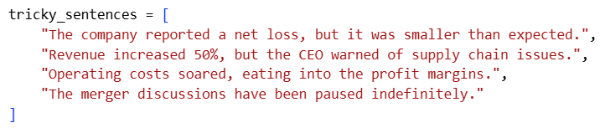

Sample Output:
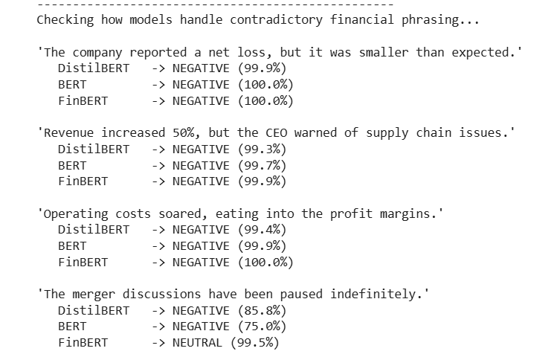
Ensemble of Transformer Models
Finally, we combined the three transformer models—DistilBERT, BERT-Base, and FinBERT—into a soft-voting ensemble. For each headline, we obtained the class probability distribution from each model and averaged these probabilities before selecting the most likely sentiment label. The individual test accuracies were 0.9439 (DistilBERT), 0.9505 (BERT-Base), and 0.9572 (FinBERT), while the ensemble achieved an accuracy of 0.9554. The ensemble slightly improved over DistilBERT and BERT-Base but remained just below FinBERT alone, suggesting that FinBERT already captures most of the useful signal, while the ensemble mainly serves as a robustness check rather than a clear performance gain.
Output:
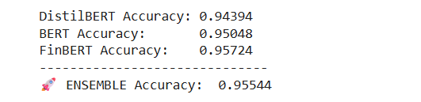

6. Streamlit Demo App
We developed an interactive Streamlit application to support experimentation and visualization of our sentiment analysis models. The app provides a simple interface for testing the performance of FinBERT, DistilBERT, and BiLSTM on demand, allowing users to observe how each model interprets financial headlines without interacting with the underlying code. This tool helped us validate model behavior qualitatively and compare how different architectures respond to identical inputs.
User Interface and Core Functionality
The application is organized into a clean two-panel layout for ease of use:
- The sidebar enables users to select from the available models, allowing direct, side-by-side comparison across architectures.
- The main interface provides a text input area where users can enter or generate financial headlines and receive real-time sentiment predictions.
Each prediction includes:
- A sentiment label (Positive, Neutral, or Negative), and
- A confidence score shown as a probability distribution, offering insight into each model’s certainty and decision boundaries.
Random Data Simulation Engine
To make experimentation more objective, the app includes a “Random Test Example” generator. Instead of relying solely on manually crafted inputs, this feature draws a headline from the unseen 20% test split and automatically runs a prediction.
When triggered, the engine:
- Selects a random unseen headline,
- Fills the input field automatically,
- Produces an instant prediction using the chosen model.
This mechanism acts as a simple blind-testing approach, helping us observe how well each model generalizes to real, uncurated financial news. It also highlights differences in robustness between models when handling varied or ambiguous phrasing.
Experimental Value
The Streamlit demo served as a practical tool throughout our experimentation. It allowed us to:
- Qualitatively inspect model outputs,
- Compare transformer models against Classical Models,
- Visualize confidence levels,
- Identify edge cases and contradictory phrasing, and
- Validate whether quantitative accuracy metrics aligned with model behavior on actual headlines.
Overall, the application provided a convenient environment for exploring model performance, understanding differences across architectures, and supporting the broader experimental analysis of our financial sentiment classification project.
Demo App: https://www.loom.com/share/a39dedccda1741e284489ed3ed0f91ba
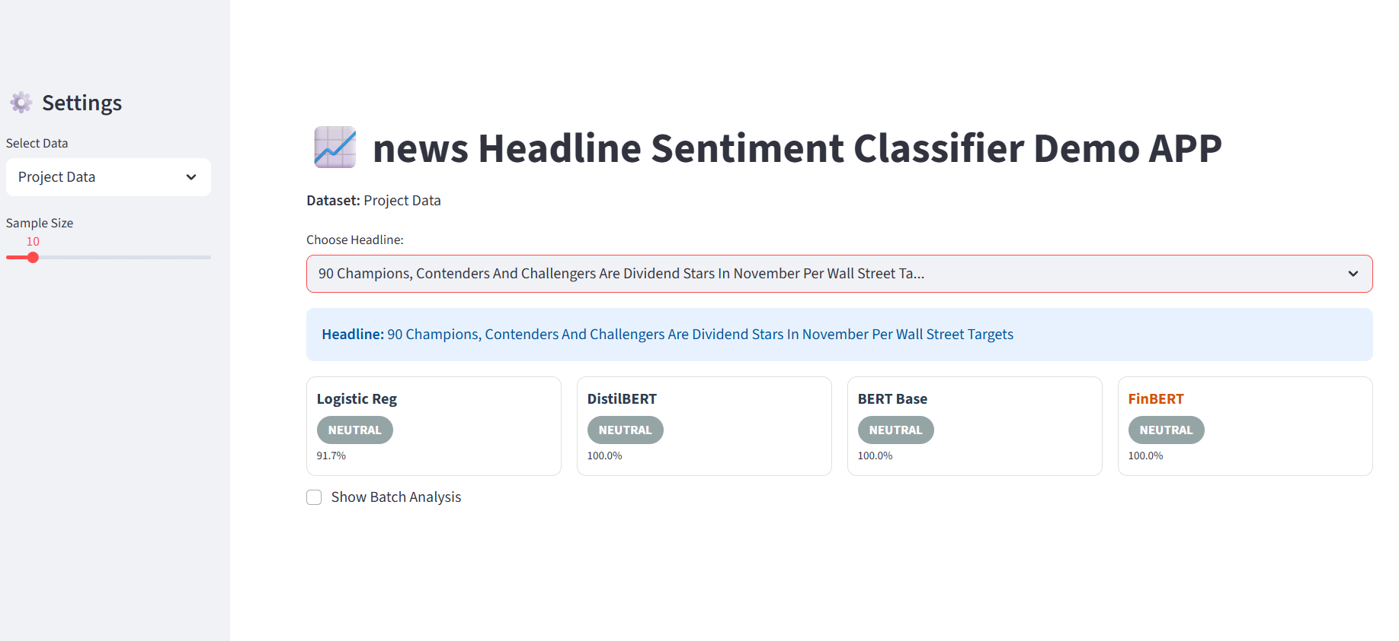
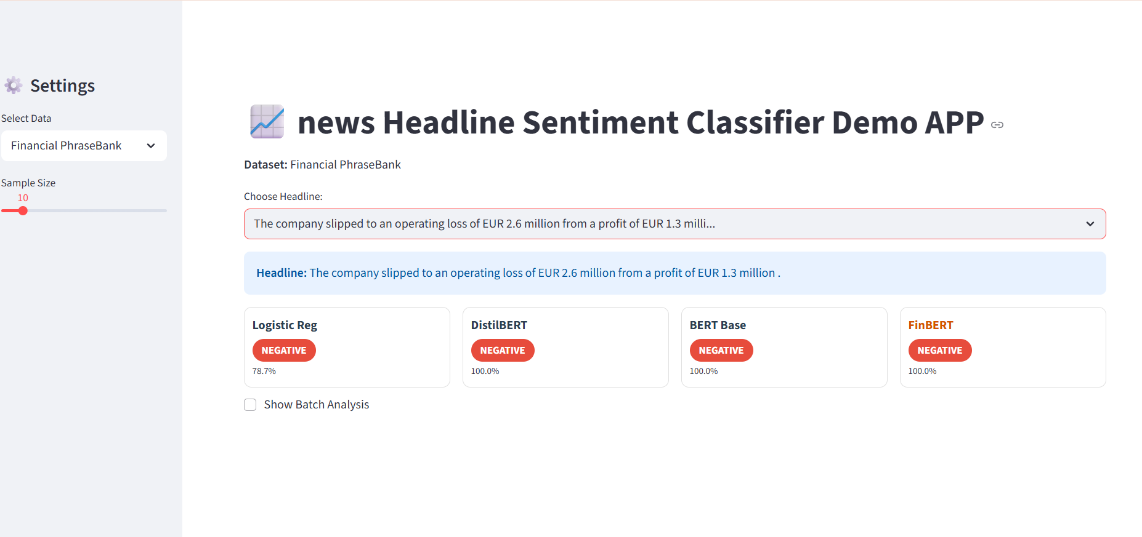
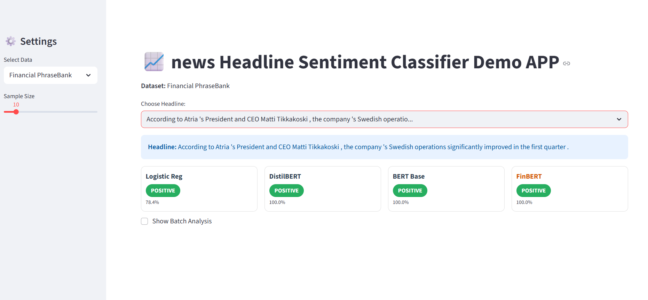

7. Conclusion:
Our early experiments using the first 10,000 headlines quickly showed the limitations of that approach. The subset didn’t capture the full diversity of the larger dataset, and as a result even our best model had trouble especially with correctly identifying positive sentiment. This made it clear that random sampling needs to be done much more carefully when dealing with imbalanced or domain-specific text.
Adding the Financial PhraseBank as a benchmark was a key step. It helped us confirm whether our labeling process was working correctly and revealed that our initial pseudo-labels were not as reliable as we thought, mainly because we had not compared them against a trusted, manually annotated dataset. Once we labeled the whole dataset with FinBERT and retrained our transformer models on the full corpus, model performance improved.
The final models not only produced strong quantitative results but also handled new, real-world financial headlines well including ambiguous sentences, as shown in our qualitative checks. In the end, using the complete dataset, validating our labels with a benchmark, and relying on domain-specific transformers were the key steps that made our sentiment classification system accurate, stable, and reliable.

8. Recommendations/Future works.
A clear next step for improving this system is to incorporate some level of human annotation into the labeling pipeline. Our current workflow depends entirely on FinBERT-generated pseudo-labels, which means we have no direct measure of how accurate the labels truly are. Creating even a small human-annotated validation set perhaps a few hundred carefully reviewed headlines would give us a reliable benchmark to evaluate FinBERT’s strengths and weaknesses. It would also help us identify cases where transformer models consistently disagree or struggle, such as headlines with subtle tone, mixed signals, or industry-specific phrasing.
Another promising direction is to expand the sentiment framework beyond the simple positive–neutral–negative triad. Financial language is rich and nuanced, and many headlines fall somewhere between categories or convey sentiment intensity rather than a clear direction. Moving toward more fine-grained labels—such as strong positive, mild positive, uncertain, or risk-alert would give analysts a deeper understanding of market tone. We could also explore event-based tagging (e.g., earnings releases, mergers and acquisitions, regulatory actions, guidance updates), which would allow the model to extract not only sentiment but also the type of financial event being described. This would make the system far more useful for real-world applications like algorithmic trading, market monitoring, and automated news analytics.
Finally, future work could evaluate additional domain-specific models or even pretrain a transformer from scratch on large collections of financial text. This might help the model better understand highly specialized terminology and subtle distinctions that general-purpose or lightly fine-tuned models often miss. Together, these improvements would make the entire sentiment-analysis pipeline more transparent, more accurate, and more aligned with the needs of practical financial decision-making.

